**Worship resource: Staff prayer**

This staff prayer was developed in a Staff Spiritual PD. The aim was to produce a prayer that staff could pray individually or corporately, which had been developed by the staff team as a whole. It was developed at a time of change in the life of the College, and serves as a reminder of our prayerful dependence upon God.

**Content of Spiritual PD**

* **Introduction to Prayer**
  + Chaplain provided a brief introduction to Prayer. What it is, why we do it, what is unique about Christian prayer.
* **Prayers from the Bible**
  + In small groups, staff were given an example of a prayer from the Bible. We looked at what was being prayed for in these passages, as a way of shaping our own priorities in prayer. The passages included:
    - Matthew 6:9-13
    - John 17:20-23
    - Colossians 1:9-12
    - Ephesians 1:15-23
    - Ephesians 3:14-21
    - Philippians 1:3-11
    - 1 Thessalonians 3:9-13
  + Staff recorded their findings on a Jamboard (as shown below)

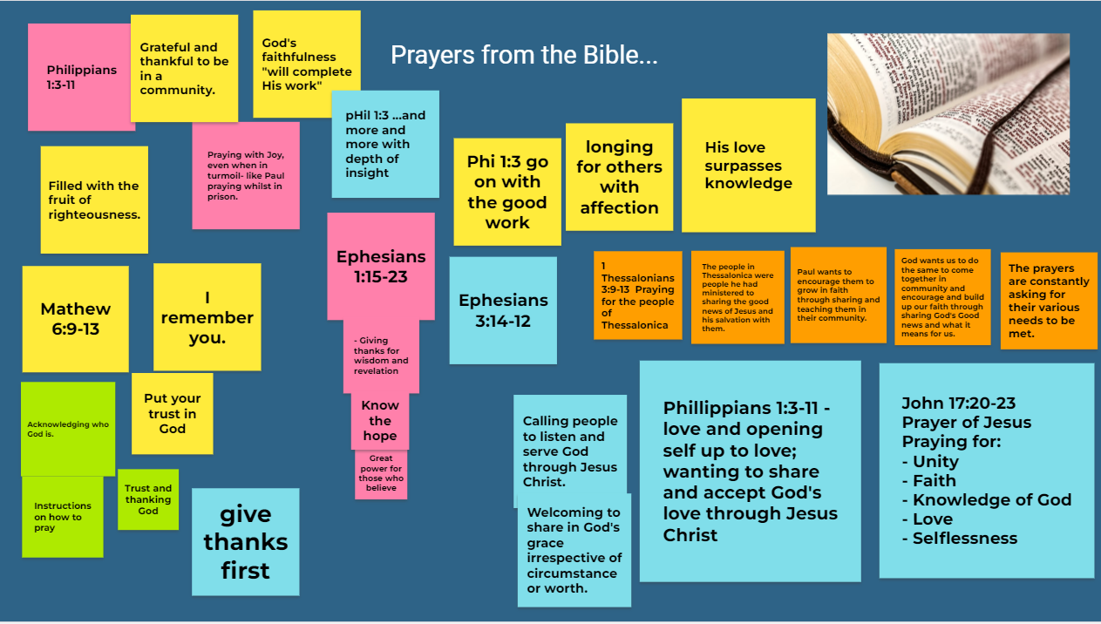

**Brainstorming Staff prayer**

* + In the same small groups, staff then began brainstorming a staff prayer for the year.
  + A number of other resources were also given for inspiration, such as some books of prayers, and “ACTS prayer template and a print out with selected prayers and blessings.
  + Again, staff provided their feedback on a Jamboard, as shown below.

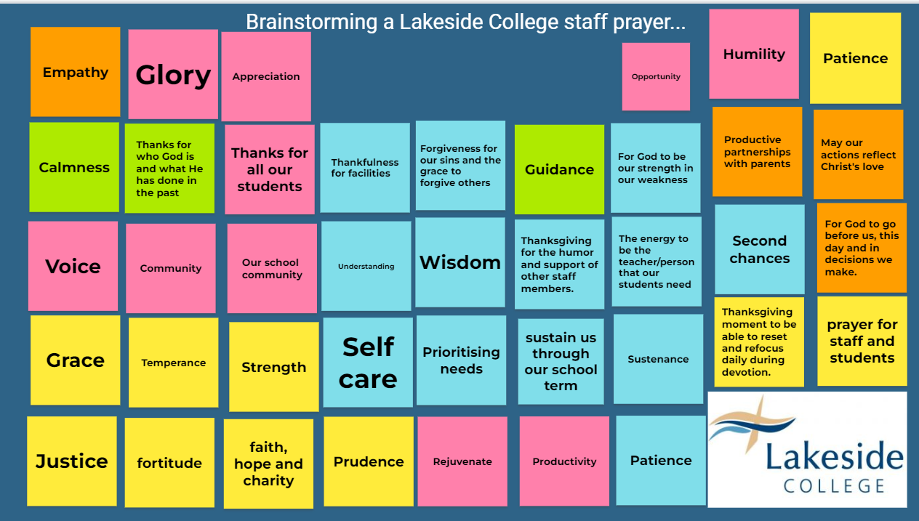

* 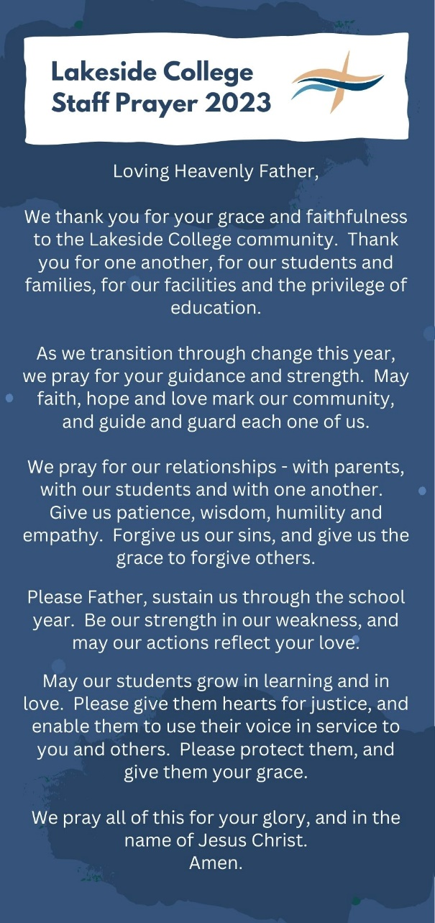**Prayer compiled and distributed**

Following this PD, the Chaplain, in consultation with a number of staff, put together a staff prayer. Simular ideas were combined, and it was edited further for brevity. The aim was, however, for the prayer to reflect the brainstorming of the wider staff.

This prayer was then prayed and distributed at a staff devotion. It has been prayed corporately, and staff have been given a copy to pray individually. Many staff have stuck up their copy in their workspace.